
Assessment Cover Sheet

Due Date
13 April 2025
Course Code
EN8911

Assessment Title
Progress Report

Course Title
Engineering Research Project

Internal Moderator’s Name
Prof. Dimitrios Mathioulakis

External Examiner’s Name
Dr. Arun Arjunan

Not must-pass
Individual
Uncontrolled
Assessment Type

Instructions:
- This cover sheet must be completed (section in red below) and attached to your assessment before submission in hard copy/soft copy.
- The time allowed for this assessment is till 13 April 2025, Time 23:59.
- This assessment carries 15 % marks and assessing CILO 1, 2 and 4.
- The use of generative AI tools is strictly prohibited.
- References consulted (if any) must be properly acknowledged and cited.
- The assessment has a total of 3 pages.

Programme Title
Learner ID
201902117
Date Submitted
16/4/2025
Learner Name

Fadhel Ali
Programme Code
Lecturer’s Name

By submitting this assessment for marking, I affirm that this assessment is my own work.
Learner Signature
Fadhel haji

Do not write beyond this line. For assessor use only.
Assessor’s Name

Marking Date

Maks Obtained

Comments:

Table of Contents
Problems and driving questions 4
Research methodology 4
Project progress 5
The measurable outcomes 8
Tasks in detail, Partial results and Conclusions 8
The most important things I have learnt 10
Area of improvement 10
The most enjoyable aspect 11
Least enjoyable aspect 11
Employability skills reflection 11
Recommendations 12

List of figures
Figure 1 Linear print 4
Figure 2 Radial print 5
Figure 3 Printed cavities & molds 5
Figure 4 Post & pre stress acting on linear actuator 6

Problems and driving questions
Pipelines play a critical role in transporting vital resources such as water, oil, and gas across various industries. However, maintaining these pipelines is challenging due to issues like corrosion, blockages, and structural degradation over time. This project focuses on designing a soft robot crawler that utilizes flexible actuators to inspect pipelines more efficiently, reduce maintenance costs, and overcome the limitations of traditional rigid inspection robots.

Key driving questions:
- How to design a lightweight, flexible robot using soft materials that can navigate small and variable pipe diameters, where traditional rigid and heavy robots are ineffective?
- What soft materials and actuator designs can provide enough movement force while remaining gentle on pipe surfaces?
- Can a soft robot crawler help reduce maintenance time and costs while offering reliable performance?
- What structure and actuation method best support controlled both radial and linear movement within confined spaces?
- What actuator geometry and material combination will provide the best balance between flexibility, durability, and motion control?

Research methodology
Information collecting & background idea: Identify the pipe sizes in which the robot will operate, ranging from 2 to 10 inches. Compare the concept and design against existing traditional rigid robots. Gather information on the most suitable materials for the robot’s construction. Review existing studies on locomotion and related topics to guide the development process, drawing insights from previously published research papers.
CAD Modeling (SolidWorks):
- The initial radial mold design was developed with a diameter of 40mm and consists of two parts that fit together to allow material pouring and casting. This design facilitates radial expansion, with three grooves around the walls that enable the filling material to expand outward.
- The linear mold was designed to feature a worm-like locomotion, allowing it to stretch along the linear axis. The design has a length of 100mm and must be capable of expanding up to 20% of its original length.

FEA Analysis (ANSYS): Before printing the design, studies were conducted on the linear part using ANSYS Workbench to assess key factors such as total deformation. This helps determine whether the linear actuator will expand and deform safely enough for effective movement. Elastic strain was also considered to evaluate contraction cycles, material wear, and the overall reliability of the design. These studies are essential to ensure the design's capability to perform its intended task effectively.
3D printing: The molds for both the linear and radial designs were printed using 3D printer devices available both on and off campus. This stage is crucial to verify that the molds designed in SolidWorks function correctly. It will also be important for the required tests to determine the effectiveness and working principles of these designs.
Pouring/Casting: After confirming that the molds were printed correctly, the material was poured into both parts. To prevent any gaps, we used a glue gun to seal the molds, ensuring that no leaks occurred, as they could interfere with the final product.

Project progress
Linear component:
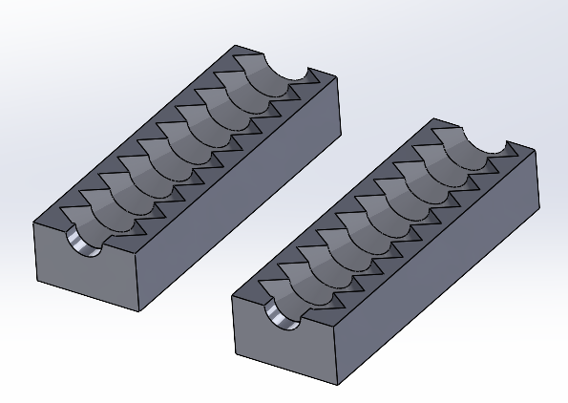
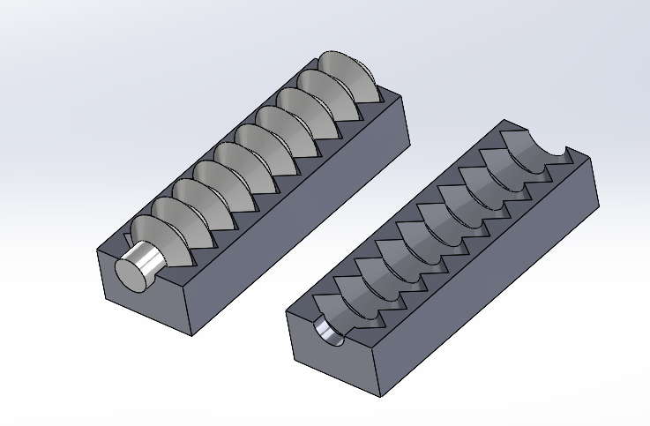
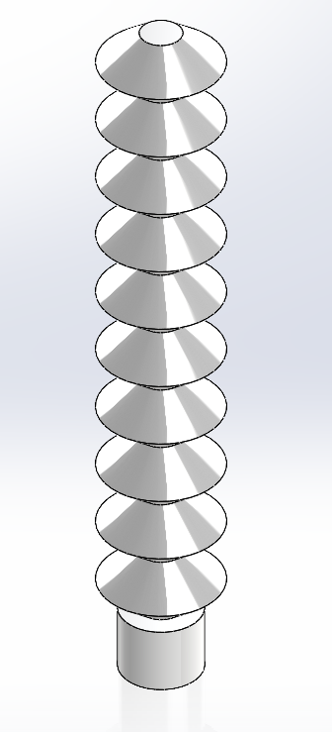
- This design incorporates a bellows structure to facilitate locomotion and features a two-piece cavity with an additional core part fixed concentrically along the walls at the bottom. The mold's end is sealed within the third part, while the top remains open for pouring the casting material. The finished cast is expected to have a length of 100mm, a wall thickness of 1mm, and a diameter of 30mm.
Figure 1 Linear print

Radial component:
- In contrast to the previous linear mold design, this part incorporates a two-part cavity with a grooved core placed internally. This design allows the material to be poured through the exposed top. Both cores are identical, each with a 40mm diameter.
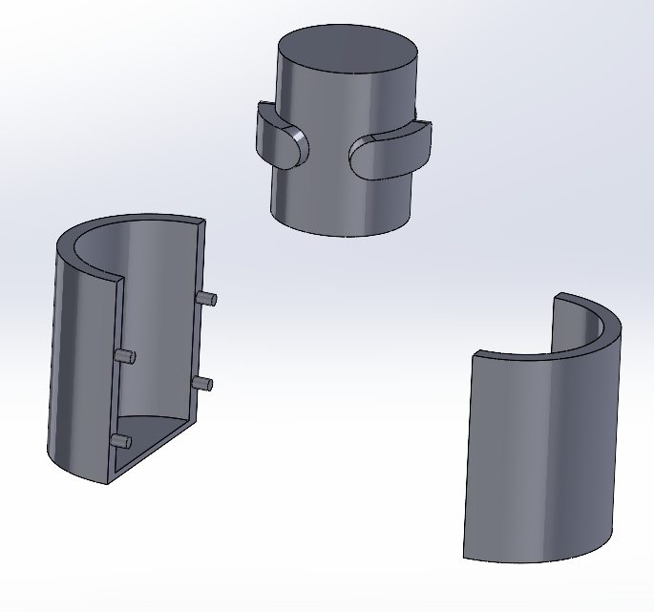
Figure 2 Radial print

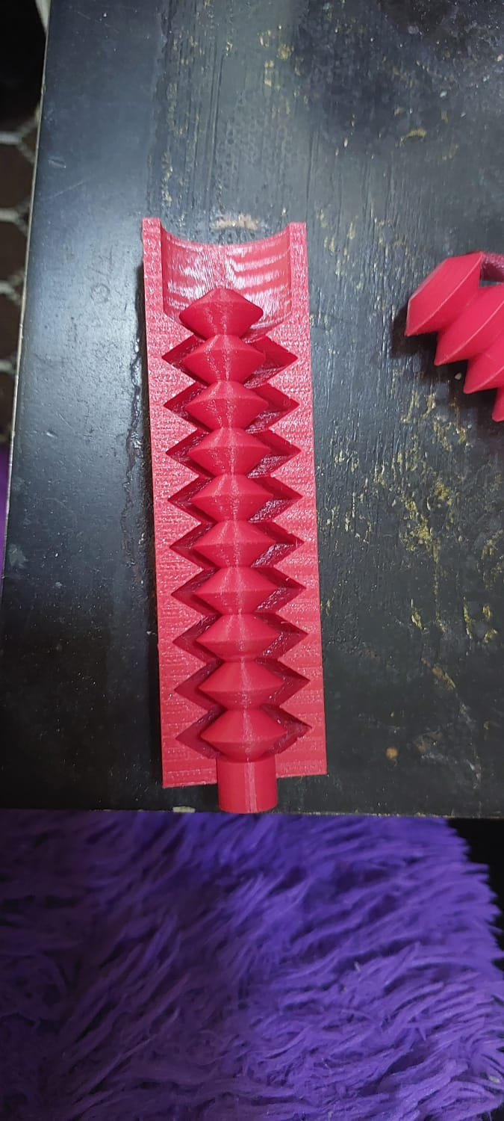
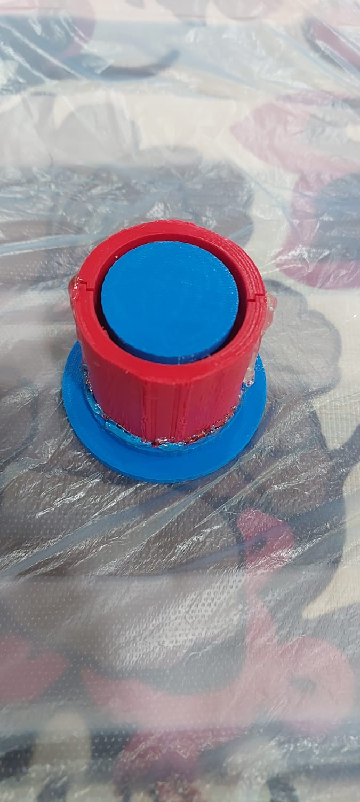
- Post printing: After the mold was printed, some areas in both designs required sanding due to geometric inaccuracies caused by filament and technical issues with the printer. Additionally, the support structures had to be carefully removed and sanded down to achieve the desired finish.
Figure 3 Printed cavities & molds

- FEA Analysis: A static/elastic structural analysis was performed in ANSYS to evaluate the behavior of the linearly expanding actuator design under simulated pressure conditions. This type of analysis is essential for soft materials, as it accurately models large, non-linear deformations typical of elastomers. The study focused on total deformation and elastic strain, revealing a 19.66% stretch from the actuator's original length.
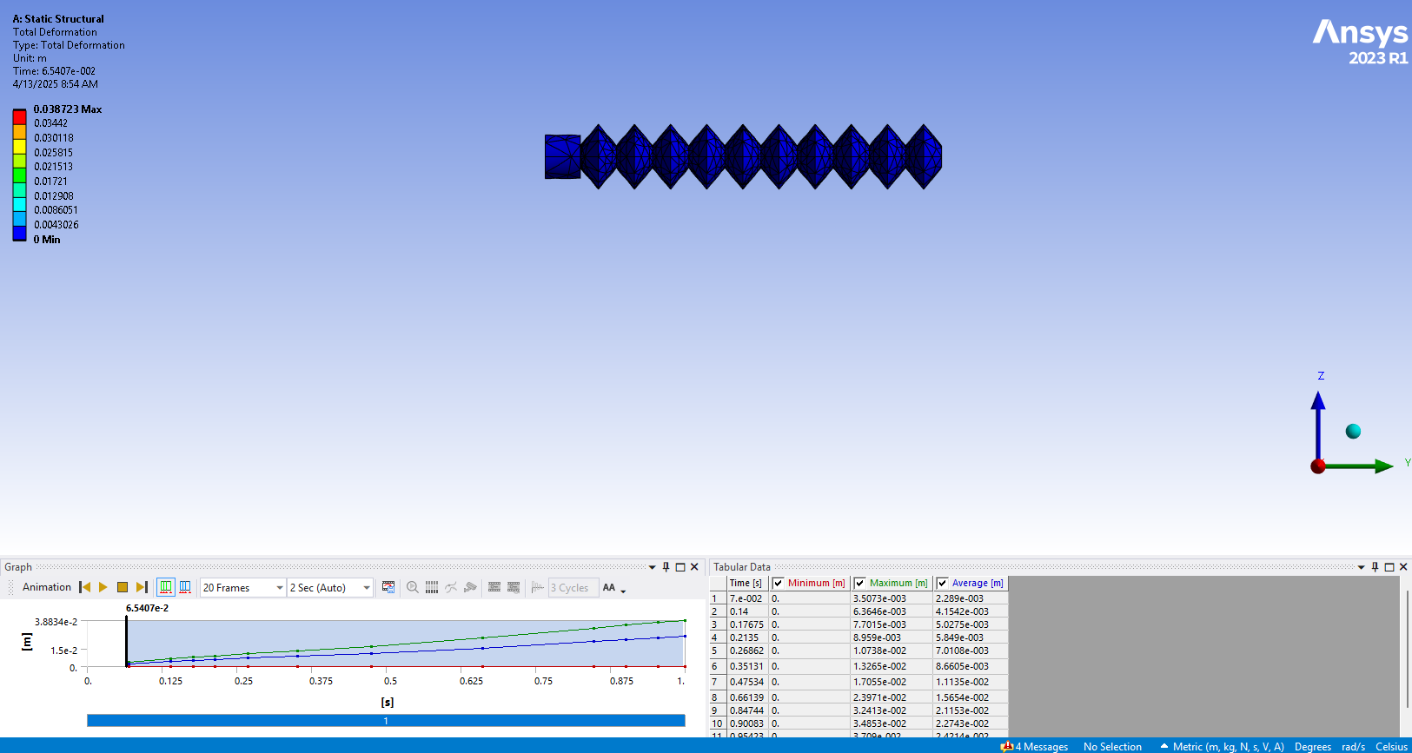
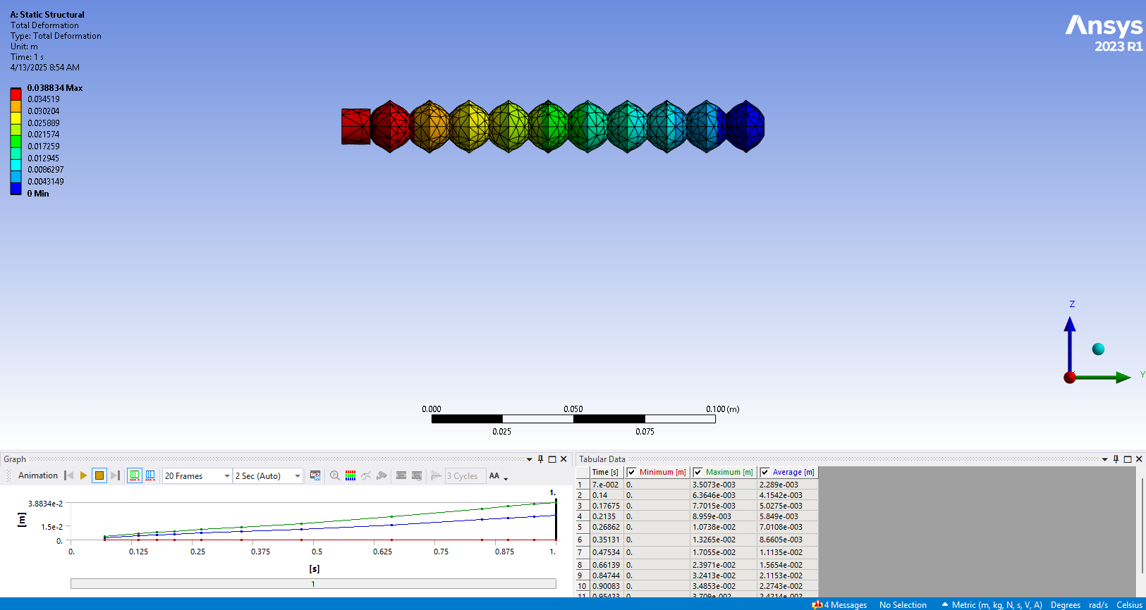
Figure 4 Post & pre stress acting on linear actuator

The measurable outcomes
- Device size: The design is optimized to navigate through pipelines using a unique form of locomotion. It is compatible with commonly used pipe materials and sizes ranging from 2 to 8 inches, ensuring smooth movement and accurate data collection throughout its operation.
- Motion: The design has been refined to move smoothly through pipes with complex geometries, both in shape and size, while maintaining reliable performance even in the presence of corrosion and other potential obstacles that could affect its motion.
- Data capture: The device will be equipped with a sensor or camera system optimized to detect blockages, corrosion, or foreign particles, providing the user with accurate and reliable feedback.
- Accessibility: The design is intended to be a low-cost bio-inspection device that stands out in the market and appeals to a wide range of companies. Its affordability offers a key advantage, making the technology accessible to a broader audience.

Tasks in detail, Partial results and Conclusions
- Research: me and my colleague Abdulla, along with our supervisor Dr. Belal ElSayed sat meetings once a week to gain experience from our supervisor’s knowledge around such topic, as well as browsed the internet for existing papers on soft materials and pneumatic actuators to understand their working mechanisms. Moreover, we identified the targeted sector behind this project, also searched for pipeline dimensions in Bahrain in opted for the most optimal for our device dimensions.
- Partial results: we developed an understanding of soft materials and pneumatic actuator mechanisms. We also successfully identified the targeted application sector, pipeline inspection.
- Conclusions: Gained valuable theoretical knowledge and insights into actuator mechanisms and soft robotics through guided discussions and literature review, forming a solid base for the design phase.
- CAD modeling: the design consists of three main components: two radial-expanding actuators at the front and rear, and a central linear actuator. The radial actuators are designed to grip the inner walls of the pipe by expanding outward when pressurized, anchoring the robot during movement. The central actuator, designed with a bellows-like structure, expands linearly to push the body forward when one of the ends is fixed.
Radial actuators where circular segments with internal arc-shaped air channels were created to enable radial expansion. Features such as shelling, fillets, and circular patterns were applied to simulate flexibility and repeatable structures.
The linear actuator was modeled as a rectangular body with bellows-like side walls, designed to expand axially.
- Partial results: The CAD models of the radial and linear actuators were successfully completed. The designs are modular and reflect the intended flexible behavior.
- Conclusions: The modeling phase established a clear structural foundation for the robot’s movement. The designs meet the functional requirements for gripping and force and are ready for simulation and prototyping in the next phase.
- FEA Analysis (ANYS workbench): The FEA analysis for the soft robot crawler linear component focused on evaluating the structural integrity and performance of the actuator under stress. Using ANSYS, material properties for silicone rubber were applied, and the internal pressure loads were simulated to assess deformation, stress distribution, and displacement. The analysis was conducted for the central linear actuator to ensure the component can withstand operational conditions without failure.
- Partial results: The linear actuator demonstrated effective axial movement with minimal deformation, and the maximum deformation was within expected operational ranges.
- Conclusion: The FEA results validate the design's structural integrity, indicating that the actuator will perform within safe limits. The analysis confirms the components’ functionality and supports its readiness for the next stage of physical prototyping and testing.
- 3D Printing and Material Pouring/Casting: The task involved 3D printing the cavities and cores, followed by material pouring/casting to create the final actuator components. While silicone rubber was poured around the cores to form the outer flexible layer. Due to geometrical differences caused by the 3D printer, the cavities required sanding to achieve the correct fit. Gaps between the printed core and cavity were sealed with a glue gun to prevent leaks. Despite these efforts, air bubbles were present in the final product, affecting the design.
- Partial results: The 3D-printed cavities and cores successfully supported the casting process. The silicone layer adhered well to the cores after sealing the gaps. However, air bubbles formed during casting, which slightly impacted the final component’s smoothness and functionality.
- Conclusion: While the combination of 3D printing and casting produced functional actuator prototypes, the presence of air bubbles indicates a need for refinement in the casting process.

The most important things I have learnt
Design and analysis: Through this project, I came to understand just how essential design is in the field of engineering as it forms the foundation of most of the work we do. While working on the component designs, I had the chance to explore new tools in SolidWorks, including the split feature, mechanical mates, and the shell function, all of which enhanced the quality and accuracy of my models. Additionally, I gained a better understanding of the importance of running simulations. I learned how stress analysis can reveal potential failure points in a design, as well as the conditions under which those failures occur. As I spent more time working with simulations, my grasp of the process and its value in predicting real-world performance significantly improved.
Problem solving: Throughout this project, I learned that not every design is practical and not every sketch will be accurate on the first try. This taught me that trial and error is a valuable part of the design process it's through testing and refining that a functional and correct design can be achieved.
The importance of communication: I realized the importance of communication throughout the project. Holding weekly meetings and having face-to-face discussions with our supervisor made a noticeable difference in how efficiently we were able to work. It helped keep the team on track and significantly boosted my own productivity, as I felt more accountable and motivated to complete my tasks. Whenever I encountered issues, I made sure to communicate directly with my teammates and supervisor, which helped us quickly find solutions and keep the project moving forward.
Integration of Different Processes: Understanding how to integrate CAD modeling, 3D printing, and material pouring/casting into one cohesive workflow was a valuable takeaway. This project emphasized the importance of selecting the right manufacturing techniques for specific components.

Area of improvement
- Refining CAD models: Ensuring greater accuracy in component fits, especially for the radial and linear actuators, would have minimized the need for adjustments later.
- Exploring alternative design iterations: Testing different geometries in the CAD phase could have led to more efficient actuator designs.
- Enhanced FEA simulations: Running more detailed simulations could have identified stress points or failure risks earlier, helping to optimize the design before prototyping.

The most enjoyable aspect
The most enjoyable part of the project was designing the parts and exploring new features in SolidWorks. It was incredibly rewarding to bring my ideas to life in the software, especially as I became more proficient with advanced tools and features like assembly design, and motion studies. The process of refining the components and ensuring they fit together perfectly was both intellectually stimulating and creatively fulfilling. Additionally, learning how to optimize designs for real-world applications and understanding the interactions between different parts gave me valuable experience in engineering design, which I can apply to future projects.

Least enjoyable aspect
On the other hand, the least enjoyable part was the trial and error process, which proved both time-consuming and energy-draining. Additionally, running simulations in ANSYS was challenging due to my lack of prior experience with the software, and it was difficult to download because of its large size, with the studies taking considerable time to run.

Employability skills reflection

1. Teamwork
- Development: I developed my teamwork skills while working with my group members on the design of the robot. We collaborated closely on the CAD modeling and FEA analysis, sharing ideas and offering feedback. This was particularly important during the iterative design process when different members contributed different perspectives.

2. Communication
- Development: Communication skills were crucial for articulating complex design concepts, especially when explaining CAD models and simulation results. I had to clearly present my findings in group discussions and later, in the final report.

3. Technology
- Development: This project heavily relied on technology, particularly SolidWorks for CAD modeling and ANSYS for FEA simulations. I developed my skills in these software tools and learned how to apply them in a real-world engineering context.

4. Self-Management
- Development: Self-management was crucial, particularly in managing my time between design work and simulations. Balancing the project with other commitments required prioritization and discipline.

5. Problem Solving
- Development: Throughout the design process, I encountered numerous challenges, such as fitting components, simulating material behavior, and dealing with the complexities of casting. I had to analyze and come up with effective solutions for these problems.

6. Initiative and Enterprise
- Development: I demonstrated initiative by actively seeking solutions to problems, such as improving the mold design to prevent air bubbles in the casting process. I also explored new features in SolidWorks that could enhance my design efficiency.

7. Planning and Organizing
- Development: I developed planning and organizational skills by setting clear goals and milestones for my tasks using a gantt chart. I structured my work in stages, ensuring all components were ready for assembly and testing.

8. Learning
- Development: Continuous learning was at the heart of this project. I learned new design techniques, CAD modeling features, and FEA methods. I also learned about the practical challenges of material casting and 3D printing.

Recommendations
To further enhance my employability skills and knowledge of the industry, I would recommend the following:
- Expand Software Proficiency: While I’ve gained strong skills in SolidWorks and ANSYS, I should further explore other simulation tools and software commonly used in the industry to broaden my technological expertise.
- Industry Exposure: Gaining real-world experience through internships or industry projects would provide deeper insights into manufacturing processes, materials, and how engineering projects are managed in practice.
- Professional Development: Continuing to attend workshops, seminars, and webinars on emerging engineering technologies will help me stay updated and improve my overall skills.

